To download these files, click on the “Clone or download” button:

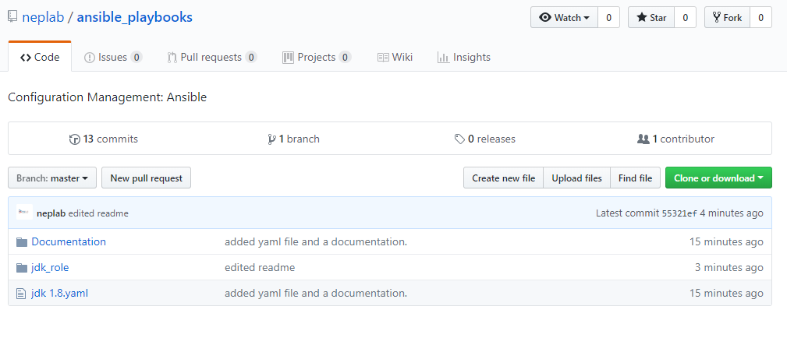

Download the zip file:

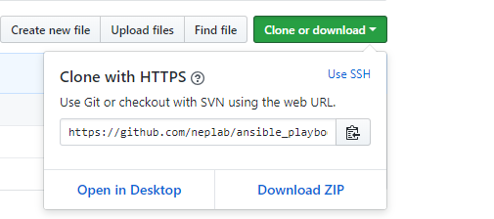

Extract the zip file and follow the documentation.

